**Q4)….**

**In NGINX:-**

yum install nginx

systemctl confstart nginx.service

cd /etc/nginx/nginx.conf

vim nginx.conf

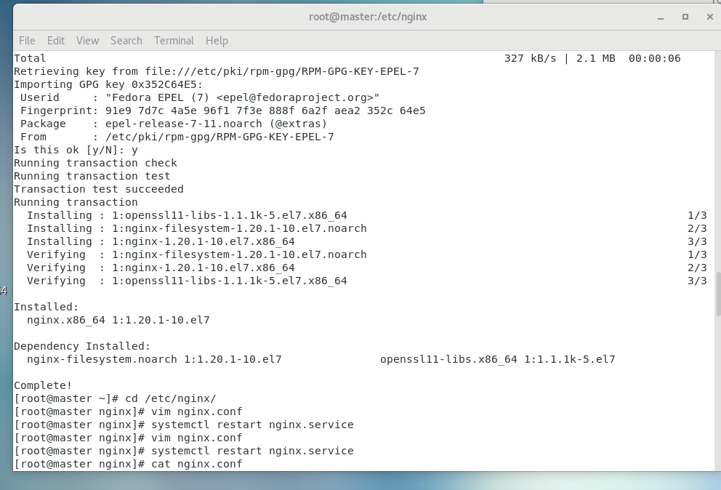

Vim nginx.conf in line no. 37

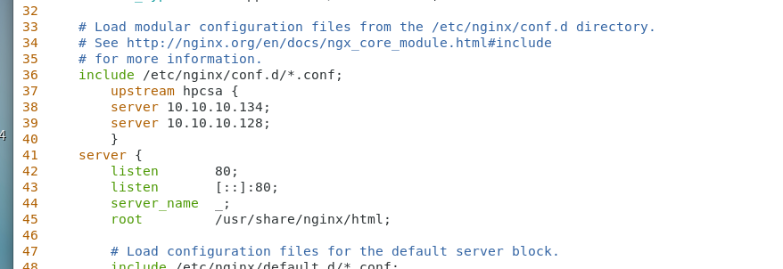

After config the nginx.config then restart the nginx service

**[root@master nginx]# vim nginx.conf**

**[root@master nginx]# systemctl restart nginx.service**

**C:\Users\rajesh\Desktop\indra\Q1\Q4\6.png**

**Then,,,,,,,,,**

**In client-1 NGINX:-**

yum install httpd

systemctl start httpd

systemctl status httpd

systemctl status firewalld

firewall-cmd --list-all

firewall-cmd --add-port=80/tcp --permanent

cd /var/www/html

vim index.html

“this is linux client.”

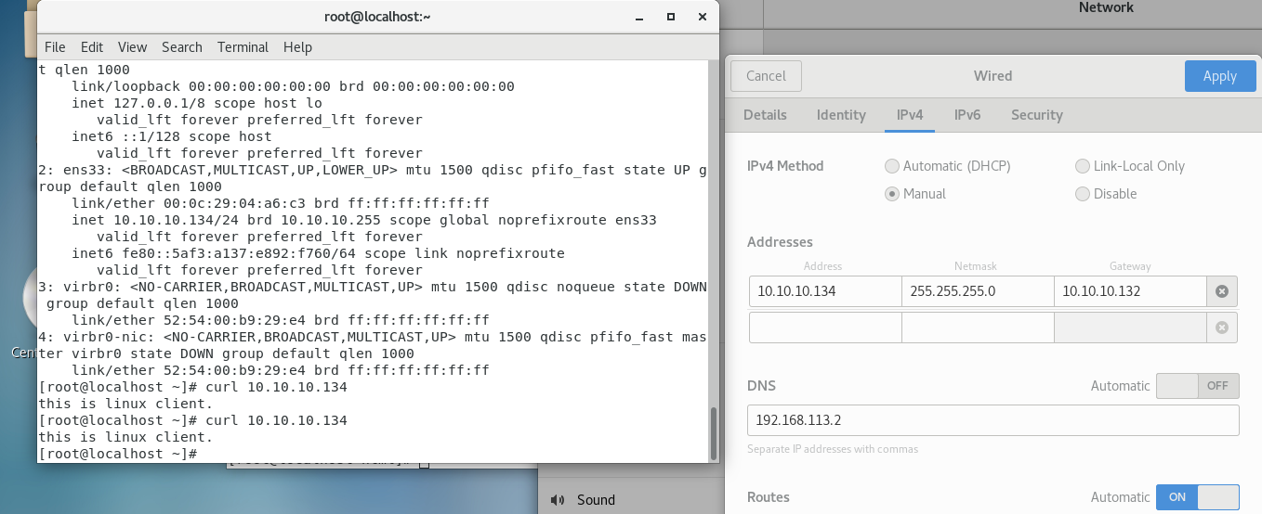

**In window-server-2 NGINX:-**

We create the index.html page in windows server🡪c drive🡪inetpub🡪wwwroot🡪index.html

“this is windows client”

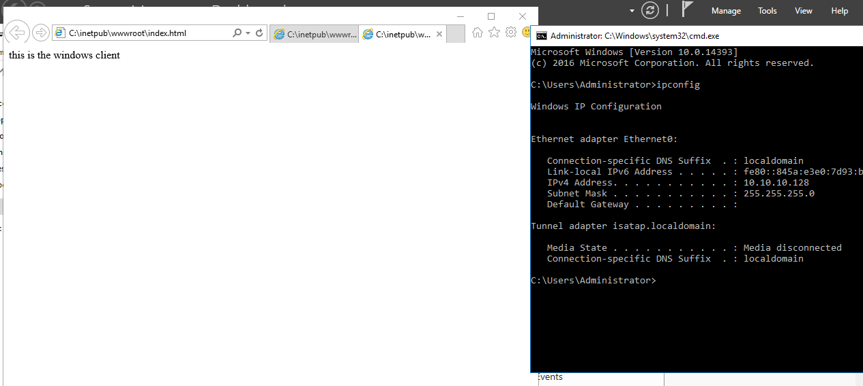

Then search on NAT ip of nginx server(192.168.113.146)

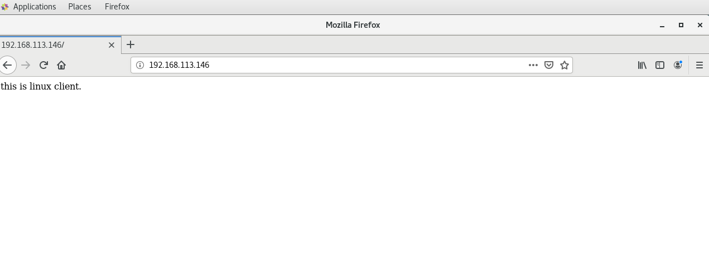

Then referesh it so it see the another window client machine..

